PRESS RELEASE - EFFECTIVE IMMEDIATELY – 6th JULY 2011

DEALING WITH DESTINY – GIVING VARIETY CHILDEREN A DESTINY and BETTER LIFE BY HELPING TO RAISE FUNDS FOR VARIETY THE CHILDERENS CHARITY.

Sydney – 6th July 2011 – Effective Immediately – Paul Condoleon, the producer of the new Australian Indie film ‘Dealing With Destiny’ and Blue Pie Productions have teamed up with variety Australia to raise funds for Australian children.

Dealing With Destiny, Blue Pie and Variety Australia have teamed up to raise funds for the disadvantaged children of Australia. Funds will be raised via a combination of a raffle for fans to win the car in the film as well as other music prizes and an online auction of several pieces of iconic rock’n’roll memorabilia including memorabilia of The Beatles and Australia’s renowned modern “pop” artist Martin Sharp.

These iconic memorabilia pieces will be placed for auction to create a bidding frenzy for all of the world to bid on. Amongst the memorabilia items there will be The Beatles Royal Command Performance Program (in complete form) from November 4th 1963 that is signed by John Lennon, George Harrison, Paul McCartney, Brian Epstein, Marlene Dietrich and several iconic artists from the 60s; a very rare complete set of Japanese mono pressings of The Beatles Albums in "see-through" red vinyl from 1982, in total mint condition; and a iconic Cold Chisel Album Artwork collectable item that was created by and painted by Martin Sharp.

Working with David Small and Anita Smith from Variety, Blue Pie CEO Damien Reilly is thrilled to start the auction this August. As Damien Says:

“The auction will be promoting Australian Independent films, and the release of Dealing With Destiny under a new business model that has never been done before. The film’s producers have been great and my team at Blue Pie have worked very hard to get this to all come together so that we can support the kids that need help the most. It’s our destiny to give these kids a destiny and with the help of companies like Hoyts, we can give independent films a new life through a great new business model. Business with benevolence is the model that we should all try to work towards and help out those that need a helping hand like Variety.”

The film is set for release in Hoyts Cinemas in various locations across Australia from the 1st of September 2011. The films premier will be in the Fox Studios Sydney with formal announcements to follow.

Special thanks go to Martin Sharp, Angelica Greening, Paul and James Condoleon and The Reilly Family for their contributions to the auction.
For all updates on the auction, and if you’d like to bid for one of these fabulous items, visit the Variety Australia website at www.variety.org.au or head to www.dealingwithdestiny.com !

PHOTO:
Damien Reilly and Martin Sharp:

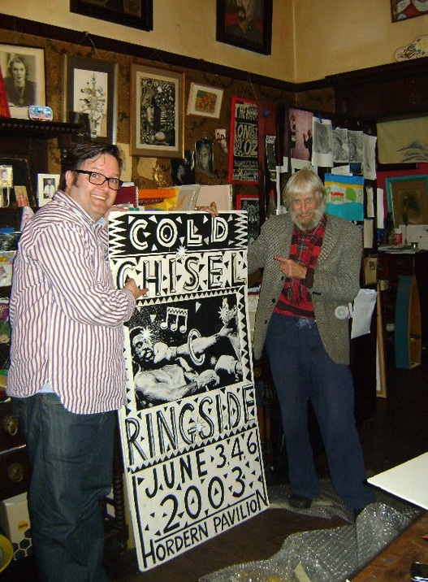

About Variety Australia:
www.variety.org.au

Variety, the Children’s Charity is a national not-for-profit organisation empowering children who are sick, disadvantaged or who have special needs. All donor funds raised are directed back into the local communities of Australia.

With the help of dedicated volunteers and generous individual and corporate supporters, Variety, the Children’s Charity is able to offer three core programs: freedom, care and future.
It’s through these programs that Variety, the Children’s Charity can deliver a unique range of goods and services to assist with the specific needs of individual children, across a diverse spectrum of physical, emotional and financial conditions.

About Dealing With Destiny:
www.dealingwithdestiny.com
It's the last day of University term & planning of the traditional pranks is well underway between good buddies Blake, Lloyd, Vinnie, & Ricardo. Blake & Lloyd are two brilliant physics students who have always worked closely together as a partnership, but the stakes are much higher today as only one of them can top the year & win the University medal, & the somewhat sinister Professor Sorvad plots to influence the outcome.
Vinnie is called upon to drive his beloved Betsy, a 1969 canary yellow fiat sport coupe, at high speed through the campus on a desperate mission against time. Ricardo falls lustfully in love with the sexy gym girl, but she has a secret life to reveal. Lloyd has a new girlfriend, the cosmically conscious, tree-hugging, dolphin-loving Zara. Zara uses her self-styled mystical powers to read the tarot cards & to predict the future events of the day, & amazingly it all seems to be coming perfectly true - or does it?
ABOUT BLUE PIE THE RECORD LABEL:
www.bluepierecords.com

Blue Pie, the record label, is one of Australia’s leading independent labels. The label has a wide and diverse range of alliances, global partnerships and proprietary technology that we make available to all our artists, labels and content partners. These relationships combined with our technology, systems and infrastructure allow our artists and labels to reach new and exciting fan bases and markets globally. Blue Pie is proud to represent over 80 labels and over 1300 artists worldwide.

Blue Pie's artists include:
Bleek, The Devyl Nellys, Dale Bozzio, Dave Sharp, Serge Ermoll (ARIA Winner), Tony Hatch (Grammy Winner), Gordon Chambers (Grammy Winner), Janice Marie (Grammy Winner) Dave Evans (AC/DC), The Yeehaa Boys, Star Ship, John Enghauser, Evolution Eden, JP Ranger, Burning the Day, Sarah Saunders, the bLEED, Barry Crocker, Gordon Waller, Sheva, MLU, Dino Jag, and The Judes and to name a few.

Search on 'blue pie' in Google for more information.
**END***

************************************************************************
For more information:
Contact:

Press and Media Manager
Blue Pie
Unit 20 No 112 McEvoy Street
Alexandria NSW 2015
P: + 61 2 9310 0155
F: + 61 2 9310 0166
E: pr@bluepie.com.au
W: www.bluepierecords.com


************************************************************************

